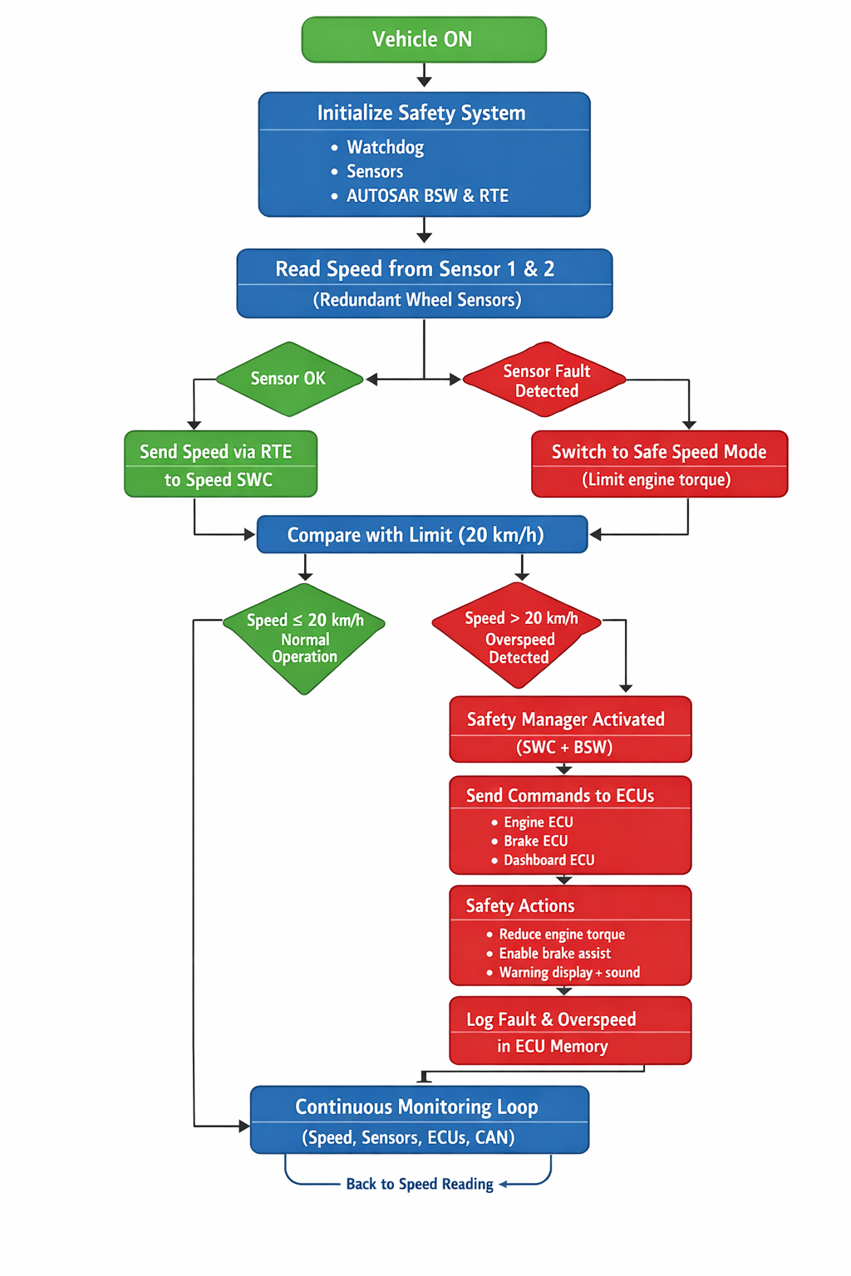
Mapping Vehicle Safety Flowchart to AUTOSAR Architecture
Our vehicle safety flowchart (speed sensing, fault detection, overspeed control) is implemented using the AUTOSAR internal architecture.
The AUTOSAR layers involved are:
HARDWARE → MCAL → BSW → RTE → APPLICATION (SWCs)

1. Sensor Data Flow
Wheel speed sensors are part of Hardware.
Their signals are read by MCAL drivers (ADC / ICU).
The Basic Software (BSW) processes and formats this data and sends it to the RTE.
The RTE delivers the speed value to the Speed Software Component (Speed SWC).
Sensor → MCAL → BSW → RTE → Speed SWC

2. Fault & Overspeed Detection
The Speed SWC compares the speed with the limit (20 km/h).
The Safety SWC checks sensor faults and safety conditions.
Both SWCs receive all data only through the RTE.

3. Safety Actions
When overspeed or fault is detected, the Safety SWC decides the actions
(reduce torque, apply brakes, show warning).
These commands go back through:
Safety SWC → RTE → BSW → MCAL → Engine ECU / Brake ECU / Dashboard

4. Role of RTE
The RTE is the communication bridge between:
- Basic Software (MCAL, BSW)
- Application Software (Speed SWC, Safety SWC)
Application software never directly accesses hardware — everything passes through the RTE.

Final Conclusion
The vehicle safety flowchart is executed on AUTOSAR by using MCAL for hardware access, BSW for services, and RTE for communication, allowing the Speed and Safety SWCs to control the vehicle safely and independently of hardware.

